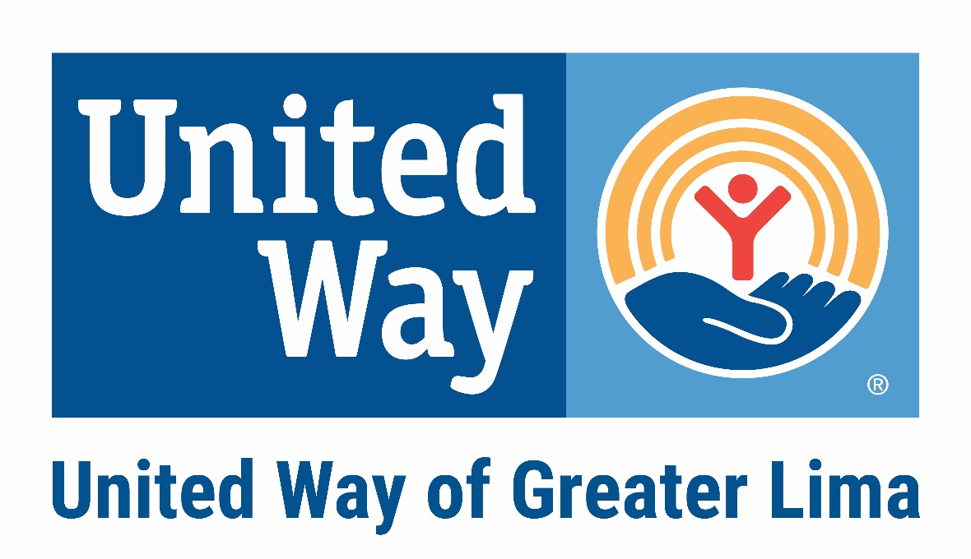

Community Partner Agencies

IMPACT STATISTICS
2022

(Published 06/01/2023)

United Way of Greater Lima – 2020-2022 IMPACT STATISTICS

 | Impact Area | Agency Name: | Program Name: | 2020 Total Served | 2021 Total Served | 2022 Total Served | Difference Between Last Two Years
1 | I | Activate Allen County | Block Parties | N/A | N/A | 1255 | N/A
2 | H | Allen County Council on Aging, Inc. | Elderly Day Care Center | 329 | 44 | 33 | (11)
3 | I | Allen County Guardianship Services Board | Allen County Guardianship Services Board | N/A | N/A | 14 | N/A
4 | FS | American Red Cross of Northeast Indiana | Disaster Cycle Services | 167 | 132 | 164 | 32
5 | ED | Arc of Allen County | Camp Robin Rogers Day Camp | 73 | 128 | 72 | (56)
6 | ED | Arc of Allen County | Robin Rogers Day Service | 51 | 141 | 37 | (104)
7 | H | Area Agency on Aging 3 | Find A Ride | 8711 | 828 | 363 | (465)
8 | ED | Big Brothers Big Sisters of West Central Ohio, Inc. | Community/School-Based Mentoring | 302 | 444 | 454 | 10
9 | FS | Black Swamp Area Council, Inc., Boy Scouts of America | Exploring | 101 | 37 | 6 | (31)
10 | ED | Black Swamp Area Council, Inc., Boy Scouts of America | Scouting (2021 estimated) | 828 | 400 | 485 | 85
11 | ED | Bluffton Area Weekday Christian Education (School Yr) | Bluffton Weekday Christian Ed Release Time | 450 | 506 | 478 | (28)
12 | ED | Bluffton Child Development Center | Bluffton Preschool and Day Care | 107 | 185 | 101 | (84)
13 | ED | Bluffton Community Preschool | Bluffton Community Preschool | N/A | 50 | 60 | 10
14 | H | Bluffton Family Recreation | Bluffton Family Recreation | 770 | 4438 | 3777 | (661)
15 | H | Bluffton Senior Citizens Association | Exercise Class | N/A | 22 | 25 | 3
16 | H | Bradfield Community Center | Healthy You....Healthy Community | 240 | 321 | 79 | (242)
17 | ED | Bradfield Community Center | My Brother's Keeper - Lima Chapter | 12 | 218 | 54 | (164)
18 | ED | Children's Developmental Center of Lima | Developmental Preschool Services | 62 | 75 | 51 | (24)
19 | H | Coleman Health Services | Wellness to Go! | 914 | 741 | 622 | (119)
20 | H | Cornerstone of Hope Lima | Resilient Kids, Teens & Families | 33 | 151 | 81 | (70)
21 | H | Crime Victim Services | Allen County Victim Court Advocacy | 2129 | 2966 | 1106 | (1,860)
22 | I | Crime Victim Services | Community listening Circles | N/A | N/A | 29 | 29
 | Impact Area | Agency Name: | Program Name: | 2020 Total Served | 2021 Total Served | 2022 Total Served | Difference Between Last Two Years
23 | H | Crime Victim Services | Violence Prevention Program | 1072 | 903 | 1238 | 335
24 | H | Crossroads Crisis Center | Residential Program | 67 | 71 | 103 | 32
25 |  | Delphos Backpack Program | Delphos Backpack Program | N/A | N/A | 62 | 62
26 |  | Delphos Sr Center | Delphos Sr Center | N/A | N/A | 178 | 178
27 | ED | Dolly Parton Imagination Library | Dolly Parton Imagination Library | 2220 | 2535 | 3152 | 617
28 | ED | Girl Scouts of Western Ohio | The Leadership Experience | 498 | 959 | 741 | (218)
29 | FS | Goodwill Easter Seals Miami Valley | Community Outreach Program | 303 | 332 | 501 | 169
30 | ED | Lima-UMADAOP, Inc. | Aiming High Program | 435 | 281 | 415 | 134
31 | FS | Our Daily Bread Soup Kitchen Inc | Our Daily Bread | 555 | 765 | 696 | (69)
32 | H | PREVENTION AWARENESS SUPPORT SERVICES | Mental Health First Aid in Lima/Allen County | 212 | 371 | 318 | (53)
33 | H | Salvation Army | After-school Program | 137 | 162 | 95 | (67)
34 |  | Salvation Army | Emergency Services | 8989 | N/A | N/A | N/A
35 | H | Senior Citizens Services, Inc. | Arthritis Aquatics | 68 | 276 | 80 | (196)
36 | H | Senior Citizens Services, Inc. | Rock Steady Boxing at SCS Lima | 120 | 135 | 43 | (92)
37 | H | Soldiers of Honor | Soldiers of Honor | 26 | 117 | 60 | (57)
38 | ED | Trinity United Methodist Church | CDF Freedom Schools Summer Program | 0 | 60 | 47 | (13)
39 | ED | West Ohio Community Action Partnership (summer program) | Kindergarten Kamp | 0 | 53 | 46 | (7)
40 | FS | West Ohio Food Bank | Feeding More Children and Families | 11869 | 3346 | 2082 | (1,264)
41 | ED | YMCA - Lima Family | YMCA STEM & Youth Development Program | 762 | 625 | 725 | 100
42 | ED | Youth for Christ - City Life/Rally Point | City Life/Rally Point | 34 | 62 | 71 | 9
43 | ED | YWCA Child Care Resource and Referral | Family Fun Learning Group | 113 | 233 | 169 | (64)
 |  |  | TOTALS | 42,759 | 23,113 | 20,168 | (2,945)

*Data from previous years has been updated based on new information received from Partner Agencies. As a result, some of the graphs will reflect a different total as not all demographic information was updated with new total number of unduplicated clients served in Allen County.
AGE | 2020 | 2020 % | 2021 | 2021% | 2022 | 2022% | Allen Co Population
0 to 5 years | 1,653 | 3.7% | 3,672 | 13.1% | 4,409 | 21.9% | 6.1%
6 to 18 years | 17,601 | 39.4% | 11,393 | 40.6% | 7,276 | 36.1% | 16.9%
19 to 24 years | 1,871 | 4.2% | 1,370 | 4.9% | 942 | 4.7%
25 to 62 years (Census counts 18-65) | 7,527 | 16.8% | 6,914 | 24.6% | 4,657 | 23.1% | 58.9%
62 and above (Census counts 65 +) | 4,258 | 9.5% | 2,540 | 9.1% | 1,567 | 7.8% | 18.1%
Age Unknown | 11,806 | 26.4% | 2,178 | 7.8% | 1,317 | 6.5% | NA
Total Served by Age | 44,716 |  | 28,066 |  | 20,168

GENDER | 2020 | 2020 % | 2021 | 2021% | 2022 | 2022% | Allen Co Population
Male | 12,199 | 27.3% | 12,741 | 45.4% | 7568 | 37.5% | 50.5%
Female | 14,945 | 33.4% | 11,063 | 39.4% | 8031 | 39.8% | 49.5%
Gender - Other | 772 | 1.7% | 625 | 2.2% | 22 | 0.1%
Gender Unknown: | 16,800 | 37.6% | 3,637 | 13.0% | 4547 | 22.5%
Total Served by Gender | 44,716 |  | 28,066 |  | 20,168

DISABILITY | 2020 | 2020 % | 2021 | 2021% | 2022 | 2022%
Male with Disability | 451 | 1.0% | 793 | 2.8% | 503 | 2.5%
Female with Disability | 373 | 0.8% | 649 | 2.3% | 397 | 2.0%
Gender-Other with Disability | 0 | 0.0% | 0 | 0.0% | 0 | 0.0%
No Disability/Unknown | 43,892 | 98.2% | 26,624 | 94.9% | 19268 | 95.5%
Total Served by Disability | 44,716 |  | 28,066 |  | 20,168

RACE/ETHNICITY | 2020 | 2020 % | 2021 | 2021% | 2022 | 2022% | Allen Co Population
African American | 1,672 | 3.7% | 3,218 | 11.5% | 2552 | 12.7% | 12.5%
American Indian or Alaska Native | 26 | 0.1% | 26 | 0.1% | 35 | 0.2% | 0.3%
Asian | 36 | 0.1% | 84 | 0.3% | 75 | 0.4% | 0.8%
Caucasian | 6,065 | 13.6% | 9,213 | 32.8% | 8509 | 42.2% | 80.6%
Hispanic or Latino | 124 | 0.3% | 281 | 1.0% | 278 | 1.4% | 3.3%
Multi-Racial | 348 | 0.8% | 852 | 3.0% | 822 | 4.1% | 3.1%
Pacific Islander | 3 | 0.0% | 4 | 0.0% | 4 | 0.0% | Z
Race/Ethnicity Unknown/Other | 36,442 | 81.5% | 14,388 | 51.3% | 7893 | 39.1%
Total Served Race/Ethnicity | 44,716 |  | 28,066 |  | 20,168

POVERTY LEVEL | 2020 | 2020 % | 2021 | 2021% | 2022 | 2022% | Allen Co Population
Above the Federal Poverty Level | 764 | 1.7% | 3,641 | 13.0% | 2810 | 13.9% | 87.1%
Below the Federal Poverty Level | 22,111 | 49.4% | 4,951 | 17.6% | 4734 | 23.5% | 12.9%
Income Level Unknown | 21,841 | 48.8% | 19,474 | 69.4% | 12624 | 62.6%
Total Served by Income | 44,716 |  | 28,066 |  | 20,168

Number Served by School District | 2020 | 2020 % | 2021 | 2021% | 2022 | 2022%
Lima | 10,622 | 23.8% | 5,799 | 20.7% | 4,844 | 24.0%
Bath | 7,301 | 16.3% | 4,537 | 16.2% | 3,630 | 18.0%
Shawnee | 4,834 | 10.8% | 3,870 | 13.8% | 2,644 | 13.1%
Elida | 3,588 | 8.0% | 3,148 | 11.2% | 2,349 | 11.6%
Perry | 5,412 | 12.1% | 2,540 | 9.1% | 2,590 | 12.8%
Bluffton | 1,894 | 4.2% | 5,322 | 19.0% | 2,018 | 10.0%
Delphos | 1,931 | 4.3% | 881 | 3.1% | 517 | 2.6%
Allen East | 1,156 | 2.6% | 1,217 | 4.3% | 933 | 4.6%
Spencerville | 725 | 1.6% | 752 | 2.7% | 643 | 3.2%
Unknown | 7,253 | 16.2%
TOTAL | 44,716 |  | 28,066 |  | 20,168

*All unknown zip codes were allocated throughout Allen County School districts in 2021 & 2022

